2019
Laura Harris

6/25/2019
The Open Door Community Project End of Year 2 Evaluation
Contents
Executive Summary 2
Background Information 2
Project Summary 3
Evaluation Overview 4
Beneficiary Change 5
Equality and Diversity 5
Outcome & KPI achievement 6
Added Value 6
Beneficiary Voice 7
Social Return on Investment 10
The Social Value Engine Introduced 10
Social Value Report 11
Social Value Summary Findings 12
Project Management & Quality 12
Project Management 12
Staff Team 12
Staff & Volunteer Training 13
Partnership Working 14
Quality, Monitoring and Evaluation 14
Areas identified for development 15

Executive Summary
St Oswald’s West End Centre (West End Centre) is a small organisation with a big heart making a huge difference to the local community and the lives of the residents.
The project runs with an in-depth knowledge of the community that it serves and an ethos of inclusion and friendship. The project has overcome real barriers that would have destroyed some projects but West End Centre has come out of adversity stronger than ever and making a bigger difference.
All but one of the KPIs has not only been met but exceeded by some margins. The reach of the project is wide and inclusive. The programme of activities meets the needs of the local community as evidenced by strong qualitative and quantitative evidence.
The staff and volunteers are outstanding, the feedback from beneficiaries regarding the staff could not have been more positive and in my interactions with staff it is clear that they are not only highly skilled and part of a dedicated organisation but that they really care about the impact they are having on people’s lives. When asked what impact they are having staff did not talk in numbers and figures but talked about building people’s confidence to achieve their life goals.
West End Centre is hugely valued by the local community for both the tangible delivery that it provides and the welcoming, friendly and supportive atmosphere, despite significant vandalism and anti social behaviours during this funding round the centre maintained its reputation and continued to attract vulnerable and grateful clients.
Without exception all the feedback I gathered was either positive or about continuous improvement – there was no negative feedback.
“A place of safety. They are not judgemental. Allows me to use my life skills to help other people”
Christmas evaluation 2018

Background Information
The West End Centre is a purpose built modern community centre based within St Oswald’s Church, Little Horton. The Centre is financially independent and distinct from the Church. Since 2005 it has represented a neutral space welcoming people of all or no faith. Originally it was a not for profit constituted organisation operating within the voluntary sector. Its legal status changed in 2013 when it became a Registered Charity and Company Ltd by Guarantee.
The organisation develops the capacity and skills of its members whom are socially and economically disadvantaged living within the local community of Little Horton and the City of Bradford in such a way that they are better able to identify their own needs, seek their own support and participate more fully in society.
The West End Centre promotes social 'inclusion' by preventing people from becoming socially excluded, relieving the needs of those people who are socially excluded and helping them to integrate into society. This benefits the community, without distinction of sex, sexual orientation, and race or of political, religious opinions.

Project Summary
Big Lottery Reaching Communities Project: Open Door Community Project
In 2014 The West End Centre was successfully awarded a Big Lottery Reaching Communities Grant over a 3 year period. In 2017 they secured a further 3 years funding and the project has continued and developed. The project was called Open Door Community Project and formed a large proportion of the work delivered by The West End Centre.
The project has evolved from previous provision funded by the BIG Lottery but is a separate project with different aims and objectives and targets. It provides a range of social, interest and learning opportunities which address the identified needs and wants of the community.
Weekly group sessions have included:
- Open Workshops
- Job Search
- Basic IT
- Functional English
- Art & Craft
- Time Out Social Group
- Performing Arts Group
- Community Lunch Club
- Games Group
- Sewing Group
- Mission Slimpossible (weight loss & healthy lifestyles group)
- Walking Group
- Bradford Depression Support Group
- Pick n mix Group (Social & Interest Group)
- Genealogy
- Skinflints Kitchen
- Safer Cooking for [people with Epilepsy.
- Internet Cafe
- Feel Good Thursday
- Tia Chi
- Community Allotment
- Green Food Bank
- Guerrilla Gardening

The Aim of the project was: To improve the quality of life of people in Little Horton and surrounding areas by engaging them in community based opportunities in order to gain skills, improve employability; and to access information enabling them to make life choices leading to better lifestyle, health and wellbeing.
Outcome 1
People will be more confident using computers to access information and services leading to improved life chances.
Outcome 2
People will be more active in the community, working together to build stronger support networks and a more resilient community.
Outcome 3
People will report increased levels of mental and social wellbeing, and feelings of community identity and belonging.

“It’s a very important hub. It’s a stone in the water with the ripples going out into the community.”
Christmas evaluation2018

Evaluation Overview
The Evaluation:
It is the intention of this report to provide an external evaluation of the West End Centre Reaching Communities Project. The organisation contracted Laura Harris, of Laura Harris Consulting to complete this work. Laura used to work for Your Consortium Ltd who are a leading voluntary sector contract management organisation and now independent Laura specialises in quality, monitoring and evaluation.
Method
The evaluation will completed through evaluating the 3 areas identified below including comparisons between the mid-way evaluation and the end of project.
Beneficiary Change
To establish through qualitative and quantitative data analysis what the provision has meant to beneficiaries and what impact it has had on their lives.
Social Return on Investment
To establish value for money and social return of this project.
Project Management and Quality
To establish good practice in delivering this type of project and provide a point of reflection to enable the organisation to learn from any issues, barriers they faced during the project.

Beneficiary Change

Equality and Diversity
The project has reached a broad spectrum of the local community shown in the below figures. It has continued its wide reach to a large cross section of the community. In comparison to the previous project figures there have been a few minor shifts in demographics including levelling out the Male/Female ratio and an increase of reach to the disabled community.
In comparison to local census data the target groups reached are very much in line with local demographics for the most part being within a few percentage points. However one particular success to highlight in relation to the target is the engagement of over 58% of clients with disabilities compared with 17% reported in the local census.
Category | Percentage Previous Project | Percentage Current Project | Local Census Percentage
Male | 56% | 50% | 50.36%
Female | 44% | 50% | 49.64%
Age 0-24 | 15.29% | 15% | 16.16%*
Age 25-64 | 77.06% | 72% | 73.16%*
Age 65+ | 7.65% | 13% | 10.78%*
Disabled | 52.35% | 58% | 17.10%
Male | 47.65% | 52% | 82.90%
Eng/Sco | 56.18% | 51% | 21.98%
Irish | 0.29% | % | 0.32%
Gypsy | 0.29% | % | 51%
AOWB | 1.18% | 4% | 6.21%
Mixed | 1.47% | 4% | 4.28%
Indian | 0.88% | 3% | 2.79%
Pakistani | 24.12% | 23% | 48.48%
Bangladesh | 1.47% | 3% | 2.31%
Chinese | 0.29% | % | 0.29%
AOAB | 2.35% | 2% | 3.87%
African | 2.94% | 4% | 2.49%
Caribbean | 3.82% | 2% | 2.63%
AOBAC | 1.47% | 2% | 0.42%
Arab | 0.59% | 1% | 1.93%
Other | 2.35% | 4% | 1.75%
Unemployed | 79.12% | 65% | 38.59%
Employed | 6.47% | 6% | 45.45%
Student | 5.59% | 14% | 8.64%
Retired | 8.53% | 12% | 7.32%
*Adjusted to show working age population only

Outcome & KPI achievement
The West End Centre has been innovative in its production of Outcomes and has split the achievements into Bronze, Silver and Gold to further define the level of impact.
All outcomes are on track to be met or exceeded and should the West End Centre measure even more of the less tangible activity and support that they provide the numbers would be exceptional.
Outcome 1  People will be more confident using computers to access information and services leading o improved life chances. | Achieved /Target | Achieved Additional
Bronze | 108/150 | 108
Silver | - | 34
Gold | - | 18
Outcome 2
People will be more active in the community, working together to build stronger support networks and a more resilient community.
Bronze | 113/150 | 113
Silver | - | 43
Gold | - | 19
Outcome 3
People will report increased levels of mental and social wellbeing, and feelings of community identity and belonging.

Bronze | 119/150 | 119
Silver |  | 42
Gold |  | 19
Platinum |  | 11

Added Value
In response to the final evaluation of the last contract the centre decided to introduce differentiation codes. Individuals achieved an outcome but often went on to strengthen or sustain the outcome generating additional evidence.

By introducing Bronze, Silver and Gold levels people were able to receive acknowledgment of further achievements. This really improved their motivation and feelings of wellbeing as assessed during discussions with numerous clients.

If an individual achieves all levels they now receive a Platinum award.
However, in terms of the contract outcomes are only counted once against the target i.e. on first achievement at bronze level.

The West End Centre has a committed team that not only measured the KPIs stated in the bid but also monitored other positive outcomes. The project supported 25 people into jobs over the project so far which is an incredible achievement. Just to show the achievement in comparison to a European Funded Project at over £3800 unit cost that has achievement targets of 19% the West End Centre has achieved an incredible 15% at half of the cost.

Beneficiary Voice
The West End Centre do a huge amount of beneficiary engagement throughout their work, below is a combination of findings from their own evaluation activities and an independent discussion with clients.
Thematic analysis of the rich qualitative data shows a huge leaning towards reducing social isolation and increasing social connectedness. The word community is used a huge amount and there is an overwhelming resonance of belonging and safety at the centre linked to huge diversity in background, circumstance and celebration of difference. Significant amounts of health improvement are attributed to the centre, physical but particularly mental health. Some examples are the centre being given credit for preventing a suicide and being the reason that someone is voluntarily running a new health support group for the community.
There are hugely impactful case studies that show not only the inclusion and support but wider outcomes and impacts surrounding traditional gender role, refugees and wider issues.
Case Study 1
My name is Sandra and I am 44 years old. I was told about the Centre by my Mental Health Nurse. I was looking for things to do with my days and wanted to find someone who could understand about my feelings about bereavement and grief. I phoned and spoke to Fran, we communicated over a few days sometimes by text. This gave me confidence to visit the centre and after the first week I decided that this was the place I wanted to be and that it would be able to help me get back on my feet. I felt really lost.
The people in the group are all so friendly and make me feel really at ease. It’s being able to talk to other people who are going through the same things and understand how difficult it is just leaving the house or doing everyday things like going to the supermarket. People smile at you and ask how you are but you can’t tell them. It’s really hard when you feel really sad but you do want to get better. The main thing for me was that I didn’t want to live my life depressed and full of grief. I felt like I was stuck with a great big duvet of grief wrapped around me. Some mornings I couldn’t move further than the settee.
The group helped me by improving my confidence and my belief that I can do things and believe in myself. At first Sue a volunteer arranged to meet me at the bus stop in town as I was frightened of getting lost. I could find so many reasons not to do things. For me I needed to know what bus, where it went from and what time, all these things can make me panic and then I wouldn’t go. I have been lost a couple of times since but Sues always managed to rescue me by phone.
Just having someone to talk to about your week and how things have gone is massive. For me personally it has totally changed me, I not the scared, terrified person that I was. It’s still a bit scary but now I know I have support.
The biggest change is applying for a place at Bradford College. I worked in Health & Social care for over 22 years and loved it until my illness which meant I just couldn’t work. I was ill for 2 years whilst struggling to work and then lost my job as a result. I haven’t worked for 4 years. I was going to apply for a place on the Health and Social Care but!!!! I decided that I really wanted to train to be an electrician. It sounded ridiculous in my head but guess what!? I’ve done it. I enrolled today and have my official badge. I start my course on the 3.9.18.
I was really nervous but I imagined my group with me as I sat there, supporting me and giving me the confidence to do what I really wanted to do. It’s amazing, I’ve come so far I felt so sad and didn’t think I could be happy again.
When I start my course I can still come to the group which is amazing because I don’t want to miss it. Even if I do have fears, which I am sure I will have, I can come and talk about it.
I would just like to thank everyone for being so supportive and making me feel I can do anything I want. Fran told me I could.
Case Study 2
I’m David , I’m 26 and I have schizophrenia. My hobbies are repairing computers and now cooking.
Before I came to the centre I was inside all day doing nothing productive. I didn’t have many friends, and I was depressed because I was always on my own.
My support worker brought me to the West End Centre to see if I liked it. Before I came I was nervous and I thought I would get lost, so the first time she drove me. When I first came in I saw Fran one of the staff, she told me about the different groups I could come to and I decided to come to the cooking group. Sue told me about which busses I could get and I got the centre phone number in case I got lost!
When I joined the cooking group I was very quiet but I learned about healthy eating and cooking skills. After a bit I joined the walking group too. Since then I have also joined the Friends in need depression support group, that has helped me by talking to people that are the same as me, you talk to some people and they don’t understand you, but the people in the group do.
Since I have come to the centre I get out of bed early, I used to stay in bed all day. I have stopped smoking, I eat better, and I have made friends, I feel more confident talking to people
I have applied for a voluntary job helping older people with technology so my life had definitely changed!
If someone was thinking about coming to the centre, I would say just to come, it’s cool and you are supported.
The annual Community consultation event was held at The West End Centre in April .
Aim:
- To talk and listen to people in order to understand people’s hopes and fears for their communities and themselves.
- To establish the future needs and wants of the community.
- To identify impact and good practice at the Centre.
- To better understand what we can do to provide people with the ability to make informed choices and to improve their life chances.

Method:
An initial general meeting took place where the agenda for the day was discussed along with the aims and objectives of the event. People formed themselves in five focus groups, they were free to join which ever group they felt comfortable with. Staff and a member of the Management Committee facilitated groups inviting discussion around a list of questions designed to guide the process and focus discussion. At the end of the discussion groups were asked if they felt any additional areas should have been addressed and if they wanted to add anything else.

Summary of findings:
Peoples Hopes for their Communities
- More visible Policing
- Better access to NHS Services, GPs and Dentists
- Investment in the Community, better maintenance of lighting, litter bins, public toilets etc
- Increase in Youth Services
- More accessible information about what’s available in the community, better access to web based information.
- A more respectful, safer and resilient community
Peoples Hopes for themselves
- To feel safe
- Not to be isolated
- For opportunities to meet others and socialise
- For community provision to be holistic and based on the person not their personal characteristics or post code
- To have better access to information, help and support
- To get help with job search, debt, etc
- To be able to access Health related support, disability, mental health etc.
Areas of good Practice at the Centre were identified as:
- A welcoming atmosphere
- Provision tailored to the individual
- Flexible provision
- Non hierarchical structure
- All welcome
- Good food, opportunities to eat with others
- Encouragement of mutual support networks and friendships
- Confidentiality
- Opportunities for volunteering
- Self governing groups
- A positive can do culture of acceptance
Impact of provision; people feel
- More connected within the community
- Safer
- Less isolated
- Able to support each other
- Listened to
- Valued, useful
- More confident
- Increased sense of well being and self esteem
Future needs and wants
- Increased capacity / physical space
- Longer opening times
- Opportunities to develop computer skills tailored to individual need
- Community based access to the internet
- Support with unemployment, job search etc
- Support with Mental health issues
- Help to access NHS services and increase awareness of health issues
- More opportunities for social interaction, opportunities to eat together etc
- More community based trips, outings etc
- Opportunities to exercise and increase physical activity
- Increased opportunities for community involvement and influencing decision making within the community.
- Access to information and support services
- Person centred provision
- Holistic approach to developing provision

Social Return on Investment

The Social Value Engine Introduced
The Social Value Engine is a tool that has been developed by Rose Regeneration and East Riding of Yorkshire Council that identifies over 120 fully-researched proxies which can be used robustly to measure and evidence impact. This is a major refinement; in many cases SROI impacts are based on weakly researched or abstract proxies, which can bring the process into disrepute. The proxies are grouped into the 8 domains within widely accepted Bristol Accord matrix (set out below), which represent an EU accepted approach to measuring the sustainability of settlements.
This engine identifies social value by setting out:
- The monetary value of each outcome.
- The contribution of the outcome to the sustainability of the community.

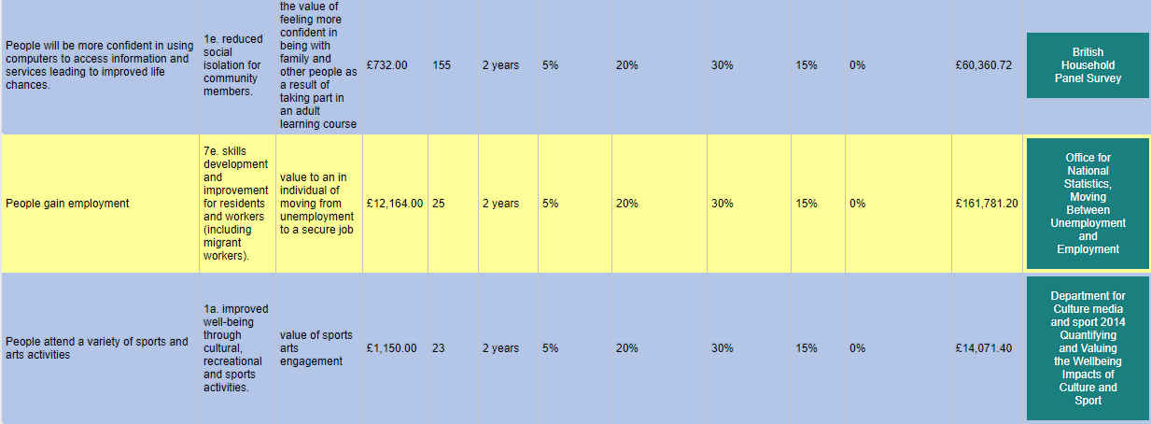
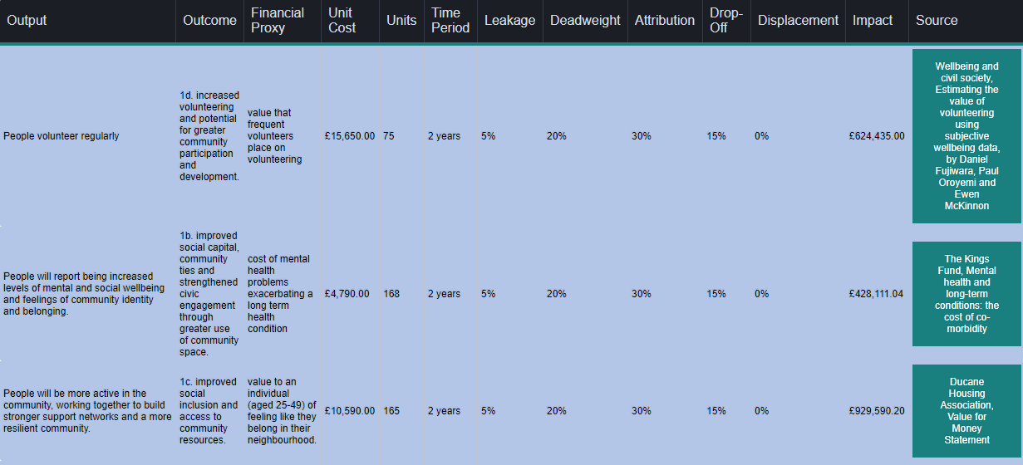
Social Value Report

Social Value Summary Findings
The social return on investment into this project is good at over £12 per pound. This is an estimate based on monitoring completed during the project (a more accurate representation can be given if social value monitoring is planned from the start of a project).
Predominantly West End Centre’s intervention sits within the ‘Active, Inclusive and Safe’ area of the Bristol Accord. This fits well with their mission and the feedback from participants.
The key returns for this project are:
- Volunteering – 75 beneficiaries (half of participants) volunteered through this programme. This links closely with feedback directly from participants that volunteering helps them with their confidence and their health and wellbeing. I also strongly believe that many of the volunteers would not have accessed mainstream volunteering and it is the unique supportive nature of the environment that encourages such numbers.
- Employment – 25 beneficiaries were able to gain employment through the programme which is a fantastic figure.
- Improved Health and Wellbeing – significant feedback is present regarding support with Mental Health and wellbeing improvements.

Project Management & Quality

Project Management

The West End Community Centre Management Committee is made up 11 Trustees from a cross section of the community and individuals from major organizations such as Bradford Community College and The Community Mental Health team within the NHS. Board members include an experienced Business Manager and Lawyer, A Senior College Lecturer and Lead for Health & Social Care, A Community Psychiatric Nurse, A recently retired Assistant Head teacher, service users and local residents. The board are recruited for the skills and experience that the organisation requires to thrive, and they are actively involved in the project having a good understanding of service delivery and the requirements of the service users. They meet on a regular basis.
New trustees are issued with a Trustee Induction Pack which includes copies of all policies & procedures. The Chair and Centre Manager completes inductions to familiarise the Trustees with the Vision and Culture of the Centre and its aims, objectives, current position and delivery.
Policies and procedures are reviewed by the board annually for their effectiveness and practicality.
The West End Centre also has a Steering Group for this project; West End Community Forum which reports to the Management Committee, the group meets quarterly and ensures the centres beneficiaries and volunteers are involved in all aspects of the running and monitoring of the centre and its activities.

Staff Team
The current Centre Manager has over 20 years of Contract Management experience in the voluntary sector and has been involved in OFSTED and ALI inspections working for Grade 1 organizations. They also have considerable experience of developing pilot projects working with disadvantaged groups.
The Centre Manager is qualified to Level 7 in Business Improvement and Contract Management qualification. She has 30+ years experience in the sector having successfully managed a range of contracts and grants including ESF, ERDF, Job Centre Pulse, Big Lottery, Henry Smith, Tudor Trust, Near Neighbours and a range of grass root grants.
Project staff includes an experienced Community Development and Monitoring Officer who has 20+ years experience working in Health & Social care and as part of NHS. They have successfully developed methods of engaging members of the community, delivering groups and developing systems of recording and evaluating the impact of the project.
The functional Skills Learning Champion post has been split into a job share position to maximise skill level and balance it with functionality. This has enabled the Centre to develop innovative approaches to engagement, delivery and evidencing impact.

Staff & Volunteer Training
The organisation has placed great value on developing itself and its staff team to ensure they continue to develop and grow as individuals and as an organisation.
Staff and volunteers have undertaken training in impact and quality in order to support the team to be more involved with the development of the organisation and its’ systems. This is in keeping with the admirable continuous improvement culture within the organisation.
Volunteers
Volunteers have been involved from the conception of the project by talking to them to find out what "they" think, want and need.
They have been engaged in:
- Marketing, promoting provision, inputting information etc on the website with news on community sessions
- Helping to set up and prepare for groups and activities.
- Providing one to one support and to befriend beneficiaries.
- Receiving feedback from beneficiaries,
- The steering group which shapes the development of the project ensuring it continues to be relevant to their needs.

Over the lifetime of the project there have been 75 active volunteers. These include students, work placements and beneficiaries.
A total of over 5758 volunteer hours have been donated over the first two years of this project which is a testament to the commitment and culture prevalent at the centre.
This is not including the countless hours that have been undertaken by beneficiaries with acts of kindness and giving the centre a helping hand when needed.
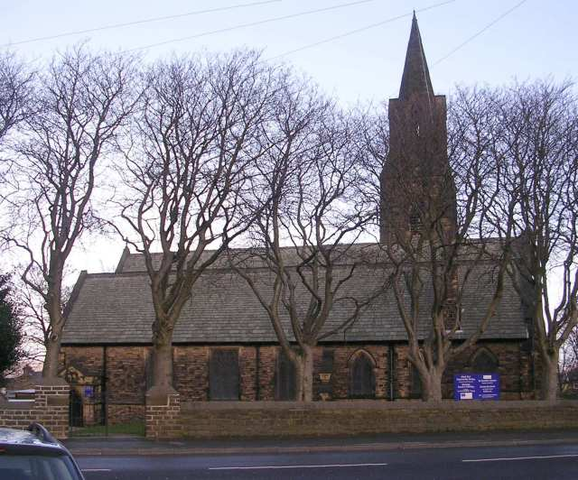
The Premises
The West End Centre is a purpose built modern community centre based within St Oswald’s Church. It has a main meeting room which holds up to around 60 people, a fully equipped IT suite, small office space, a kitchen area and access to the church as and when required.
They also have 2 allotments locally with a Poly tunnel, raised beds and a shed.
One piece of feedback from beneficiaries does highlight the potential need to physically expand, in particular the IT facilities. Though this was tempered with a need not to become big and impersonal.

Partnership Working
The West End Centre works within its local community in its entirety including partnership working with local agencies:
Bradford College:
- Providing placements for Health & Social Care Students and Youth and Community Students. Helping to develop the Health & Social Care provider’s forum.
National Citizens:
- Working together to support young people to gain skills and engage in community based fund raising and activities.
Yorkshire Building Society:
- Helping to support the community by providing staff and skills to support projects.
Bradford Council:
- Delivering council tax and debt advice in the heart of the community.
- Working with council wardens to support the local community, address issues, do litter picks and deliver the neighbourhood plan.
Tesco:
- Combating poverty by enabling the community to access food that would otherwise have gone to land fill.
Volunteering Bradford:
- Provision of volunteering opportunities.
Reed Employment Agency:
- Provision of placements helping individuals gain work experience, build confidence, access a reference and improve their employability.
Job Centre Plus:
- Provision of sheltered placements for people with additional support needs.
- Provision of placements which help individuals gain work experience, build confidence, access a reference and improve their employability.
- Helping people gain skills to be able to do their own job search.
- CV writing, employability skills etc.
- Providing access to the internet for people who are digitally excluded so that they can make fresh claims, under take job search and evidence job search activity in order to not have benefits sanctioned etc.
Creative Support:
- Provision of community based activities in a safe environment.
Community Psychiatric Services:
- Supported groups and activities for people with mental health issues and people experiencing depression, lack of confidence and anxiety.
Local GPs and Health Centres:
- Training Practice Health Champions to teach patients at their surgeries to; access NHS Services On Line, Book appointments, Request repeat prescriptions On Line, use health apps etc. To increase their awareness of other Community based groups and activities and refer interested patients to them.
Champions Show the way:
- Sharing space and providing a venue for groups and activities.
- Helping deliver activities.
The School of Eternal Light: (ofsted report 2019 outstanding in all areas)
- Providing Health & Social Care placements for students.
- Joint litter picks.
- Support of public meeting to address Anti Social behaviour in the area.
The Police:
- Holding public meetings in order to engage the community and support to address Anti Social Behaviour in the area.
- To provide a focal point for the community and keep an ASB Log.
- Provision of a Fortnightly Police drop in building relationships and trust, facilitating community engagement.

Quality, Monitoring and Evaluation
Outputs and Outcomes are identified gridded up and monitored against for all contracts and grants. This system is under constant development to ensure continuous improvement is embedded throughout the organisation.
Staff and committee members are aware of outcomes and outputs on an ongoing basis and review them together. The organisation also holds ‘Uglies’ meetings where staff, volunteers and committee members can air any difficulties that they are having in order to get collaborative support.
They have a data protection and a security policy which has recently been reviewed and upgraded, covers and a range of systems for the identification, collection and analysis of both hard and soft outcomes.
Staff and volunteers are involved in the evaluation and monitoring of provision.
Regular detailed reports are produced for funders in line with their requirements.
Tutor observations are carried out by relevant experienced and qualified staff /trustees.
Detailed registration documents have been designed to collect relevant data.
ILPs /PDP have been developed.
RAPRA systems have been developed and improved upon to ensure that they are not just a tick box exercise and are understood by all.
The staff team has developed new methods of monitoring, evaluating and evidencing outcomes. They have a system that is very comprehensive and works well for the Open door Community Project. They continue to develop in this area and are currently looking at a way of measuring the project’s Impact across the whole organisation.

Areas identified for development
There are a small number of areas of development:
Physical Space – both beneficiaries and staff suggested that a bigger space would be useful
Consistency in Monitoring – as the ethos of the centre is to continuous improvement this has led to some inconsistencies in recording data. As a result of the previous evaluation the centres database was upgraded, its improvement is under constant review and is ongoing.
Further development and implementation of impact measurement within the evidencing and recording of data could be useful in order to identify additional soft outcomes and social value.

Conclusion
In conclusion The West End Centre is a small enterprise making big waves in its community. The professionalism with which it is run never detracts from the person-centred approach and it is one of the few small organisations that manage to strike the balance between highly professional with a focus on monitoring while keeping the front line service warm, friendly and effective.
The statistics speak for themselves and the few case studies that I was able to include without making this report many pages long with testimonials speak volumes for the impact of the services provided.
The community is diverse and the breadth and quality of the offer meets the needs of so many of the local community and categorically improves their quality of life.

